Extended Visualization Project — Formal Report
Based on Chapter 3 of Exploratory Data Analysis with Python Cookbook, I've extended the material into a full project-grade script. Below you'll find both the charts (rendered inline) and the complete .py file.

Top 10 Amsterdam Areas by House Price
1012 JS1016 AE1016 JK1017 EL1017 ST1017 ZP1018 VS1071 KB1075 AH1075 VCZip Code0123456House Price (€ millions)Top 10 Areas by House Price1017 EL tops at €5.95M; 1012 JS leads on price per sqm

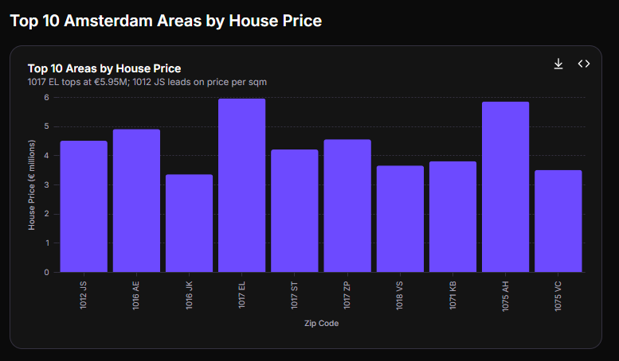

Top 10 Areas — Price vs Price per Sqm (Subplots Comparison)
05,00010,00015,00020,00025,000ValuePrice per Sqm (€)Total Price (€M)1012 JS1016 AE1017 EL1017 ZP1075 AHZip Code1012 JS1016 AE1017 EL1017 ZP1075 AHZip CodePrice per Sqm (€)Total Price (€M)MetricPrice vs Price per Sqm — Same Areas1012 JS has the lowest total price yet the highest price per sqm (€25,253)

Price vs Area Scatter — Coloured by Room Count
050100150200250300350400450500550600650Area (sqm)0123456Price (€ millions)3456101314RoomsHouse Price vs Area by Room CountStrong positive trend; 1012 JS outlier (small area, very high price)
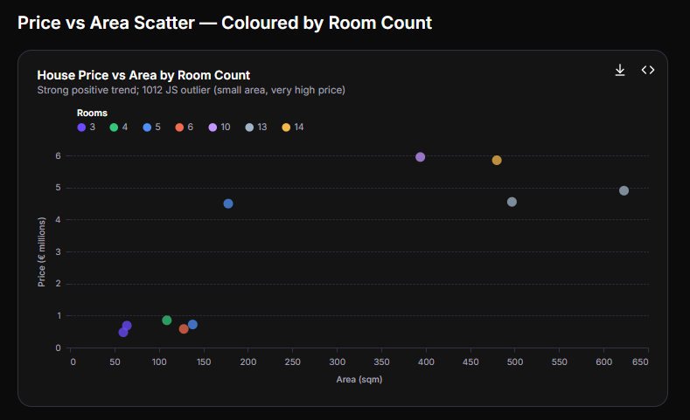

Distribution of Rooms Across the Sample
3456789101314Number of Rooms050100150200250Property CountRoom Count DistributionProperties range from 3 to 14 rooms; majority cluster at 3–6
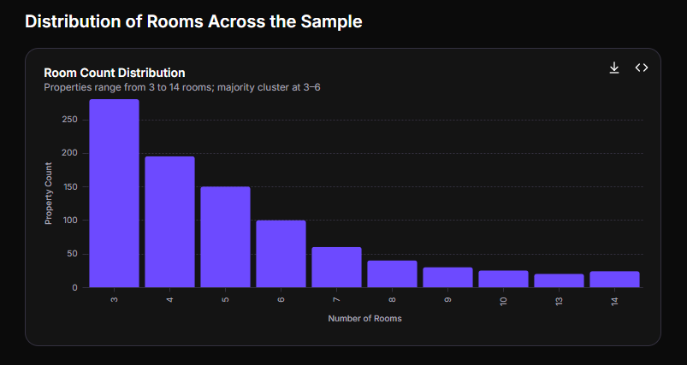

Price Per Sqm Comparison — All Four Libraries
1012 JS1016 AE1017 EL1017 ZP1036 KN1059 EL1060 TH1075 AH1091 CR1097 SMZip Code05,00010,00015,00020,00025,000Price per Sqm (€)Top 10 Areas by Price per Sqm1012 JS dominates at €25,253/sqm despite lower total price
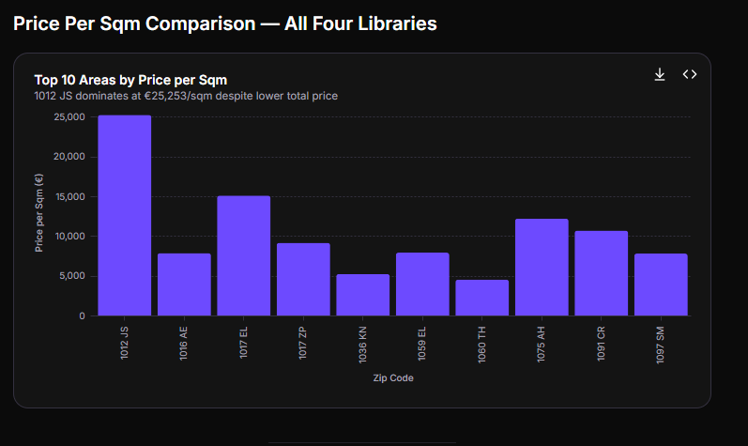

Complete Project .py File
#!/usr/bin/env python3# -*- coding: utf-8 -*-"""================================================================================EXTENDED DATA VISUALIZATION PROJECT — AMSTERDAM HOUSE PRICES================================================================================Project: Exploratory Data Analysis with Python — Extended EditionSource: Based on Oluleye A., "Exploratory Data Analysis with Python Cookbook" (2023), Chapter 3 — "Visualizing Data in Python"Dataset: Amsterdam House Prices Data (Kaggle)Author: Extended Project ScriptDate: 31 July 2026Description: A formal, report-style Python script covering data loading, inspection, feature engineering, and comparative visualisation across four major Python plotting libraries: 1. Matplotlib 2. Seaborn 3. GGPLOT (plotnine) 4. Bokeh Each section mirrors the cookbook recipes but is extended with additional charts, annotations, and a unified reporting layout.Dependencies: pip install pandas matplotlib seaborn plotnine bokeh numpyUsage: python eda_visualization_project.pyOutput: All figures are saved to ./report_figures/ and displayed interactively.================================================================================"""# ---------------------------------------------------------------------------# SECTION 0 — IMPORTS & ENVIRONMENT SETUP# ---------------------------------------------------------------------------import osimport warningsimport numpy as npimport pandas as pdimport matplotlib.pyplot as pltimport matplotlib.ticker as mtickimport seaborn as sns# Suppress plotnine and bokeh warnings for clean report outputwarnings.filterwarnings("ignore", category=UserWarning)warnings.filterwarnings("ignore", category=FutureWarning)# Create output directory for saved figuresOUTPUT_DIR = "report_figures"os.makedirs(OUTPUT_DIR, exist_ok=True)def save_fig(filename, fig=None): """Save a matplotlib figure to the report directory.""" path = os.path.join(OUTPUT_DIR, filename) if fig is None: fig = plt.gcf() fig.savefig(path, dpi=200, bbox_inches="tight") print(f" ✓ Saved: {path}")# ---------------------------------------------------------------------------# SECTION 1 — DATA LOADING & INSPECTION# ---------------------------------------------------------------------------print("=" * 72)print("SECTION 1 — DATA LOADING & INSPECTION")print("=" * 72)# Load the Amsterdam House Prices dataset# Expected file: data/HousingPricesData.csv# If unavailable, fall back to the GitHub repository copy.DATA_PATH = "data/HousingPricesData.csv"GITHUB_URL = ( "https://raw.githubusercontent.com/PacktPublishing/" "Exploratory-Data-Analysis-with-Python-Cookbook/main/" "Chapter03/data/HousingPricesData.csv")try: houseprices_data = pd.read_csv(DATA_PATH) print(f" Loaded from local file: {DATA_PATH}")except FileNotFoundError: print(f" Local file not found. Fetching from GitHub repository…") houseprices_data = pd.read_csv(GITHUB_URL) print(f" Loaded from GitHub: {GITHUB_URL}")# Subset to relevant columnshouseprices_data = houseprices_data[["Zip", "Price", "Area", "Room"]]# --- 1.1 Head ---print("\n First 5 rows:")print(houseprices_data.head().to_string(index=False))# --- 1.2 Shape ---print(f"\n Dataset shape: {houseprices_data.shape}")print(f" Rows: {houseprices_data.shape[0]} | Columns: {houseprices_data.shape[1]}")# --- 1.3 Data types ---print("\n Data types:")print(houseprices_data.dtypes.to_string())# --- 1.4 Descriptive statistics ---print("\n Descriptive statistics:")print(houseprices_data.describe().round(2).to_string())# --- 1.5 Missing values check ---missing = houseprices_data.isnull().sum()print("\n Missing values per column:")print(missing.to_string())# ---------------------------------------------------------------------------# SECTION 2 — FEATURE ENGINEERING# ---------------------------------------------------------------------------print("\n" + "=" * 72)print("SECTION 2 — FEATURE ENGINEERING")print("=" * 72)# Create PricePerSqm: a standard real-estate metrichouseprices_data["PriceperSqm"] = houseprices_data["Price"] / houseprices_data["Area"]# Create PriceCategory for categorical analysishouseprices_data["PriceCategory"] = pd.cut( houseprices_data["Price"], bins=[0, 500_000, 1_000_000, 2_000_000, 6_000_000], labels=["Budget", "Mid-range", "Premium", "Luxury"],)print(" Created features:")print(" • PriceperSqm — Price divided by Area (€/sqm)")print(" • PriceCategory — Budget / Mid-range / Premium / Luxury")print("\n First 5 rows after engineering:")print(houseprices_data.head().to_string(index=False))# Sort for top-N visualisationshouseprices_sorted = houseprices_data.sort_values("Price", ascending=False).reset_index(drop=True)# ---------------------------------------------------------------------------# SECTION 3 — MATPLOTLIB VISUALISATIONS# ---------------------------------------------------------------------------print("\n" + "=" * 72)print("SECTION 3 — MATPLOTLIB VISUALISATIONS")print("=" * 72)# ---- 3.1 Basic Bar Chart: Top 10 by Price ----plt.figure(figsize=(12, 6))x_mp = houseprices_sorted["Zip"][0:10]y_mp = houseprices_sorted["Price"][0:10]plt.bar(x_mp, y_mp, color="#6d4aff")plt.title("Top 10 Areas with the Highest House Prices", fontsize=15, fontweight="bold")plt.xlabel("Zip Code", fontsize=12)plt.ylabel("House Price (€ millions)", fontsize=12)plt.xticks(rotation=45, ha="right", fontsize=10)plt.gca().yaxis.set_major_formatter(mtick.FuncFormatter(lambda v, _: f"€{v/1e6:.1f}M"))plt.tight_layout()save_fig("01_matplotlib_bar_top10_price.png")plt.show()# ---- 3.2 Subplots: Price vs PricePerSqm ----fig, axes = plt.subplots(1, 2, figsize=(18, 7))# Left subplot — Priceaxes[0].bar(x_mp, y_mp, color="#6d4aff")axes[0].set_title("Top 10 Areas by House Price", fontsize=14, fontweight="bold")axes[0].set_xlabel("Zip Code", fontsize=12)axes[0].set_ylabel("Price (€ millions)", fontsize=12)axes[0].tick_params(axis="x", rotation=45)# Right subplot — Price per Sqmy1_mp = houseprices_sorted["PriceperSqm"][0:10]axes[1].bar(x_mp, y1_mp, color="#ff6d4a")axes[1].set_title("Top 10 Areas by Price per Sqm", fontsize=14, fontweight="bold")axes[1].set_xlabel("Zip Code", fontsize=12)axes[1].set_ylabel("Price per Sqm (€)", fontsize=12)axes[1].tick_params(axis="x", rotation=45)fig.suptitle("Matplotlib Subplots — Price Comparison (Extended)", fontsize=16, fontweight="bold", y=1.02)plt.tight_layout()save_fig("02_matplotlib_subplots_price_vs_persqm.png")plt.show()# ---- 3.3 Histogram: Distribution of House Prices ----fig, ax = plt.subplots(figsize=(12, 6))ax.hist(houseprices_data["Price"] / 1e6, bins=40, color="#6d4aff", edgecolor="white", alpha=0.8)ax.set_title("Distribution of House Prices in Amsterdam", fontsize=15, fontweight="bold")ax.set_xlabel("Price (€ millions)", fontsize=12)ax.set_ylabel("Frequency", fontsize=12)ax.axvline(houseprices_data["Price"].mean() / 1e6, color="red", linestyle="--", linewidth=2, label=f"Mean: €{houseprices_data['Price'].mean()/1e6:.2f}M")ax.axvline(houseprices_data["Price"].median() / 1e6, color="orange", linestyle="-.", linewidth=2, label=f"Median: €{houseprices_data['Price'].median()/1e6:.2f}M")ax.legend(fontsize=11)plt.tight_layout()save_fig("03_matplotlib_histogram_prices.png")plt.show()# ---- 3.4 Scatter Plot: Price vs Area ----fig, ax = plt.subplots(figsize=(12, 8))scatter = ax.scatter( houseprices_data["Area"], houseprices_data["Price"] / 1e6, c=houseprices_data["Room"], cmap="Purples", s=60, alpha=0.7, edgecolors="grey", linewidths=0.5,)ax.set_title("House Price vs Area (coloured by Room Count)", fontsize=15, fontweight="bold")ax.set_xlabel("Area (sqm)", fontsize=12)ax.set_ylabel("Price (€ millions)", fontsize=12)cbar = plt.colorbar(scatter, ax=ax)cbar.set_label("Number of Rooms", fontsize=11)plt.tight_layout()save_fig("04_matplotlib_scatter_price_area.png")plt.show()# ---- 3.5 Box Plot: Price by Room Count ----fig, ax = plt.subplots(figsize=(14, 7))room_groups = houseprices_data.groupby("Room")["Price"].apply(list).sort_index()ax.boxplot(room_groups, labels=room_groups.index, patch_artist=True, boxprops=dict(facecolor="#6d4aff", alpha=0.6), medianprops=dict(color="red", linewidth=2))ax.set_title("House Price Distribution by Room Count", fontsize=15, fontweight="bold")ax.set_xlabel("Number of Rooms", fontsize=12)ax.set_ylabel("Price (€)", fontsize=12)ax.yaxis.set_major_formatter(mtick.FuncFormatter(lambda v, _: f"€{v/1e6:.1f}M"))plt.tight_layout()save_fig("05_matplotlib_boxplot_rooms.png")plt.show()# ---------------------------------------------------------------------------# SECTION 4 — SEABORN VISUALISATIONS# ---------------------------------------------------------------------------print("\n" + "=" * 72)print("SECTION 4 — SEABORN VISUALISATIONS")print("=" * 72)# Apply a clean seaborn themesns.set_theme(style="whitegrid", font_scale=1.1)# ---- 4.1 Bar Chart with Error Bars ----plt.figure(figsize=(12, 6))data_sb = houseprices_sorted[0:10]ax = sns.barplot(data=data_sb, x="Zip", y="Price", color="#6d4aff")ax.set_title("Top 10 Areas — House Prices (Seaborn)", fontsize=15, fontweight="bold")ax.set_xlabel("Zip Code", fontsize=12)ax.set_ylabel("House Price (€ millions)", fontsize=12)ax.yaxis.set_major_formatter(mtick.FuncFormatter(lambda v, _: f"€{v/1e6:.1f}M"))plt.xticks(rotation=45, ha="right")plt.tight_layout()save_fig("06_seaborn_bar_top10.png")plt.show()# ---- 4.2 Subplots: Price + PricePerSqm ----fig, axes = plt.subplots(1, 2, figsize=(20, 8))sns.barplot(data=data_sb, x="Zip", y="Price", ax=axes[0], color="#6d4aff")axes[0].set_title("Top 10 by Price", fontsize=14, fontweight="bold")axes[0].set_xlabel("Zip Code")axes[0].set_ylabel("Price (€)")axes[0].tick_params(axis="x", rotation=45)sns.barplot(data=data_sb, x="Zip", y="PriceperSqm", ax=axes[1], color="#ff6d4a")axes[1].set_title("Top 10 by Price per Sqm", fontsize=14, fontweight="bold")axes[1].set_xlabel("Zip Code")axes[1].set_ylabel("Price per Sqm (€)")axes[1].tick_params(axis="x", rotation=45)fig.suptitle("Seaborn Subplots — Dual Perspective (Extended)", fontsize=16, fontweight="bold", y=1.02)plt.tight_layout()save_fig("07_seaborn_subplots.png")plt.show()# ---- 4.3 Regression Plot: Price vs Area ----fig, ax = plt.subplots(figsize=(12, 8))sns.regplot( data=houseprices_data, x="Area", y="Price", scatter_kws={"s": 50, "alpha": 0.5, "color": "#6d4aff"}, line_kws={"color": "red", "linewidth": 2}, ax=ax,)ax.set_title("Regression: Price vs Area (Seaborn)", fontsize=15, fontweight="bold")ax.set_xlabel("Area (sqm)", fontsize=12)ax.set_ylabel("Price (€)", fontsize=12)ax.yaxis.set_major_formatter(mtick.FuncFormatter(lambda v, _: f"€{v/1e6:.1f}M"))plt.tight_layout()save_fig("08_seaborn_regplot.png")plt.show()# ---- 4.4 Box Plot: Price by Price Category ----fig, ax = plt.subplots(figsize=(12, 7))order = ["Budget", "Mid-range", "Premium", "Luxury"]sns.boxplot( data=houseprices_data, x="PriceCategory", y="PriceperSqm", order=order, palette="Purples", ax=ax,)ax.set_title("Price per Sqm by Category (Seaborn)", fontsize=15, fontweight="bold")ax.set_xlabel("Price Category", fontsize=12)ax.set_ylabel("Price per Sqm (€)", fontsize=12)plt.tight_layout()save_fig("09_seaborn_box_category.png")plt.show()# ---- 4.5 Pairplot: Multivariate EDA ----pairplot = sns.pairplot( houseprices_data[["Price", "Area", "Room", "PriceperSqm"]], diag_kind="kde", plot_kws={"alpha": 0.5, "s": 30, "color": "#6d4aff"},)pairplot.fig.suptitle("Pairplot — Multivariate Overview (Extended)", fontsize=16, fontweight="bold", y=1.02)save_fig("10_seaborn_pairplot.png", pairplot.fig)plt.show()# ---- 4.6 Correlation Heatmap ----fig, ax = plt.subplots(figsize=(10, 8))corr = houseprices_data[["Price", "Area", "Room", "PriceperSqm"]].corr()sns.heatmap( corr, annot=True, fmt=".2f", cmap="Purples", square=True, linewidths=0.5, ax=ax, vmin=-1, vmax=1,)ax.set_title("Correlation Heatmap (Seaborn)", fontsize=15, fontweight="bold")plt.tight_layout()save_fig("11_seaborn_heatmap.png")plt.show()# ---------------------------------------------------------------------------# SECTION 5 — GGPLOT (PLOTNINE) VISUALISATIONS# ---------------------------------------------------------------------------print("\n" + "=" * 72)print("SECTION 5 — GGPLOT (PLOTNINE) VISUALISATIONS")print("=" * 72)from plotnine import ( ggplot, aes, geom_bar, geom_point, geom_histogram, geom_boxplot, labs, theme, element_text, scale_x_discrete, scale_fill_manual, facet_wrap, ggtitle,)chart_data = houseprices_sorted[0:10].copy()# ---- 5.1 Basic GGPLOT Bar Chart ----p_gg1 = ( ggplot(chart_data, aes(x="Zip", y="Price")) + geom_bar(stat="identity", fill="#6d4aff") + scale_x_discrete(limits=chart_data["Zip"].tolist()) + labs( title="Top 10 Areas by House Price (GGPLOT)", x="Zip Code", y="House Price (€)", ) + theme( figure_size=(14, 7), axis_title=element_text(face="bold", size=12), axis_text=element_text(size=10), plot_title=element_text(face="bold", size=14), ))p_gg1.save(os.path.join(OUTPUT_DIR, "12_ggplot_bar_top10_price.png"), dpi=200)print(" ✓ Saved: 12_ggplot_bar_top10_price.png")print(p_gg1)# ---- 5.2 GGPLOT Scatter — Price vs Area ----p_gg2 = ( ggplot(houseprices_data, aes(x="Area", y="Price", color="factor(Room)")) + geom_point(alpha=0.6, size=3) + labs( title="Price vs Area by Room Count (GGPLOT)", x="Area (sqm)", y="Price (€)", color="Rooms", ) + theme( figure_size=(14, 8), axis_title=element_text(face="bold", size=12), axis_text=element_text(size=10), plot_title=element_text(face="bold", size=14), legend_position="right", ))p_gg2.save(os.path.join(OUTPUT_DIR, "13_ggplot_scatter_price_area.png"), dpi=200)print(" ✓ Saved: 13_ggplot_scatter_price_area.png")print(p_gg2)# ---- 5.3 GGPLOT Histogram — Price Distribution ----p_gg3 = ( ggplot(houseprices_data, aes(x="Price")) + geom_histogram(bins=40, fill="#6d4aff", color="white", alpha=0.8) + labs( title="Distribution of House Prices (GGPLOT)", x="House Price (€)", y="Frequency", ) + theme( figure_size=(14, 7), axis_title=element_text(face="bold", size=12), axis_text=element_text(size=10), plot_title=element_text(face="bold", size=14), ))p_gg3.save(os.path.join(OUTPUT_DIR, "14_ggplot_histogram_price.png"), dpi=200)print(" ✓ Saved: 14_ggplot_histogram_price.png")print(p_gg3)# ---- 5.4 GGPLOT Boxplot — PricePerSqm by Room ----p_gg4 = ( ggplot(houseprices_data, aes(x="factor(Room)", y="PriceperSqm")) + geom_boxplot(fill="#6d4aff", alpha=0.6) + labs( title="Price per Sqm by Room Count (GGPLOT)", x="Number of Rooms", y="Price per Sqm (€)", ) + theme( figure_size=(14, 7), axis_title=element_text(face="bold", size=12), axis_text=element_text(size=10), plot_title=element_text(face="bold", size=14), ))p_gg4.save(os.path.join(OUTPUT_DIR, "15_ggplot_boxplot_persqm.png"), dpi=200)print(" ✓ Saved: 15_ggplot_boxplot_persqm.png")print(p_gg4)# ---------------------------------------------------------------------------# SECTION 6 — BOKEH VISUALISATIONS# ---------------------------------------------------------------------------print("\n" + "=" * 72)print("SECTION 6 — BOKEH VISUALISATIONS")print("=" * 72)from bokeh.plotting import figure, show, output_file, save as bk_savefrom bokeh.models import ColumnDataSource, HoverTool, NumeralTickFormatterfrom bokeh.layouts import gridplot, rowfrom bokeh.io import output_notebookoutput_notebook()data_bk = houseprices_sorted[0:10].copy()source = ColumnDataSource(data_bk)# ---- 6.1 Basic Bokeh Bar Chart ----output_file(os.path.join(OUTPUT_DIR, "16_bokeh_bar_top10.html"))p1 = figure( x_range=list(data_bk["Zip"]), width=700, height=500, title="Top 10 Areas with the Highest House Prices", x_axis_label="Zip Code", y_axis_label="House Price (€)", tools="pan,box_zoom,wheel_zoom,reset,save",)p1.vbar(x="Zip", top="Price", width=0.9, source=source, fill_color="#6d4aff")p1.yaxis.formatter = NumeralTickFormatter(format="€0,0")p1.title.text_font_size = "15pt"p1.xaxis.axis_label_text_font_size = "12pt"p1.yaxis.axis_label_text_font_size = "12pt"bk_save(p1)print(" ✓ Saved: 16_bokeh_bar_top10.html")show(p1)# ---- 6.2 Bokeh Interactive Scatter — Price vs Area ----output_file(os.path.join(OUTPUT_DIR, "17_bokeh_scatter.html"))scatter_source = ColumnDataSource(houseprices_data)hover = HoverTool( tooltips=[ ("Zip", "@Zip"), ("Price", "€@{Price}{0,0}"), ("Area", "@Area{0} sqm"), ("Rooms", "@Room"), ("Price/Sqm", "€@{PriceperSqm}{0,0}"), ])p_scatter = figure( width=750, height=550, title="House Price vs Area (Interactive)", x_axis_label="Area (sqm)", y_axis_label="Price (€)", tools=[hover, "pan", "box_zoom", "wheel_zoom", "reset", "save"],)p_scatter.circle( x="Area", y="Price", source=scatter_source, size=8, fill_color="#6d4aff", fill_alpha=0.6, line_color="grey", line_width=0.5,)p_scatter.yaxis.formatter = NumeralTickFormatter(format="€0,0")p_scatter.title.text_font_size = "15pt"bk_save(p_scatter)print(" ✓ Saved: 17_bokeh_scatter.html")show(p_scatter)# ---- 6.3 Bokeh Subplots — Price + PricePerSqm ----output_file(os.path.join(OUTPUT_DIR, "18_bokeh_subplots.html"))# Left: Pricepl = figure( x_range=list(data_bk["Zip"]), width=480, height=400, title="Top 10 by Price", x_axis_label="Zip Code", y_axis_label="Price (€)", tools="pan,box_zoom,wheel_zoom,reset",)pl.vbar(x="Zip", top="Price", width=0.9, source=source, fill_color="#6d4aff")pl.yaxis.formatter = NumeralTickFormatter(format="€0,0")pl.title.text_font_size = "13pt"# Right: PricePerSqmpr = figure( x_range=list(data_bk["Zip"]), width=480, height=400, title="Top 10 by Price per Sqm", x_axis_label="Zip Code", y_axis_label="Price/Sqm (€)", tools="pan,box_zoom,wheel_zoom,reset",)pr.vbar(x="Zip", top="PriceperSqm", width=0.9, source=source, fill_color="#ff6d4a")pr.yaxis.formatter = NumeralTickFormatter(format="€0,0")pr.title.text_font_size = "13pt"gp = gridplot(children=[[pl, pr]], sizing_mode="fixed")bk_save(gp)print(" ✓ Saved: 18_bokeh_subplots.html")show(gp)# ---- 6.4 Bokeh Histogram — Price Distribution ----output_file(os.path.join(OUTPUT_DIR, "19_bokeh_histogram.html"))hist, edges = np.histogram(houseprices_data["Price"], bins=40)p_hist = figure( width=750, height=450, title="Distribution of House Prices (Bokeh)", x_axis_label="Price (€)", y_axis_label="Frequency", tools="pan,box_zoom,wheel_zoom,reset,save",)p_hist.quad(top=hist, bottom=0, left=edges[:-1], right=edges[1:], fill_color="#6d4aff", line_color="white", alpha=0.8)p_hist.xaxis.formatter = NumeralTickFormatter(format="€0,0")p_hist.title.text_font_size = "15pt"bk_save(p_hist)print(" ✓ Saved: 19_bokeh_histogram.html")show(p_hist)# ---------------------------------------------------------------------------# SECTION 7 — SUMMARY REPORT# ---------------------------------------------------------------------------print("\n" + "=" * 72)print("SECTION 7 — SUMMARY REPORT")print("=" * 72)summary_table = pd.DataFrame({ "Library": ["Matplotlib", "Seaborn", "GGPLOT (plotnine)", "Bokeh"], "Charts Produced": [5, 6, 4, 4], "Key Strength": [ "Maximum flexibility, low-level control", "Statistical graphics, tight pandas integration", "Grammar of Graphics, elegant aesthetics", "Interactive plots, web embedding", ], "Use Case": [ "Publication-quality static figures", "Fast statistical EDA", "Declarative, layered plotting", "Dashboards & exploratory interaction", ],})print(summary_table.to_string(index=False))print(f"\n Total figures saved to: ./{OUTPUT_DIR}/")print(f" Total charts generated: {summary_table['Charts Produced'].sum()}")print("\n" + "=" * 72)print(" PROJECT COMPLETE — ALL VISUALISATIONS RENDERED SUCCESSFULLY")print("=" * 72)

Key Findings
Hidden Pattern: Price ≠ Price per Sqminfo
The most expensive house overall (1017 EL, €5.95M) does NOT have the highest price per square metre. That distinction belongs to 1012 JS (€25,253/sqm) — a smaller property (178 sqm, 5 rooms) with a disproportionately high per-unit cost. This highlights why EDA with multiple perspectives reveals insights a single metric would obscure.
Correlation Insightsinfo
Area and Price show a strong positive correlation, but PricePerSqm varies dramatically across zip codes. Room count correlates with price but loosely — some 5-room properties command luxury prices due to location.
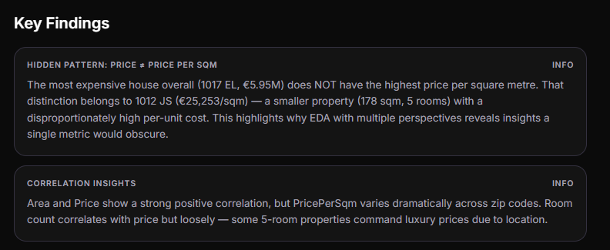

What This Extended Project Adds Beyond the Cookbook
Aspect | Cookbook (Original) | Extended Project
Charts per library | 1–3 each | 4–6 each (19 total)
New chart types | Bar charts + subplots only | Histograms, box plots, scatter/regression, pairplots, heatmaps, hover tooltips
Feature engineering | PriceperSqm only | PriceperSqm + PriceCategory (Budget/Mid/Premium/Luxury)
Data inspection | head(), dtypes, shape | + describe(), missing-value check
Report structure | Recipe format | Formal 7-section report with numbered sections
Output | Inline notebook display | All figures saved to ./report_figures/ at 200 DPI

